# TITLE PAGE

**DESIGN AND IMPLEMENTATION OF A STUDENT PORTAL (CASE STUDY OF FEDERAL POLYTECHNIC STAFF SECONDARY SCHOOL, MUBI)**

**BY**

**AKAMSHU, GABRIEL EYUAH**

**ST/CS/HND/18/018**

**DEPARTMENT OF COMPUTER SCIENCE,**

**SCHOOL OF SCIENCE AND TECHNOLOGY,**

**FEDERAL POLYTECHNIC, MUBI, ADAMAWA STATE.**

**IN PARTIAL FULFILMENT OF THE REQUIREMENT FOR THE AWARD OF HIGHER NATIONAL DIPLOMA (HND) IN COMPUTER SCIENCE.**

**MARCH, 2021**

# DECLARATION

I hereby declare that the work in this project titled “**Design and Implementation of a student portal (case study of Federal Polytechnic Staff Secondary School, Mubi)**” was performed by me under the supervision of Mr. Ahmed Aliyu. The information derived from literatures has been duly acknowledged in the text and a list of references provided. The work embodied in this project is original and had not been submitted in part or in full for any other diploma or certificate of this or any other institution.

AKAMSHU, GABRIEL EYUAH \_\_\_\_\_\_\_\_\_\_\_\_\_\_\_\_\_\_\_

(ST/CS/HND/18/018) Signature/Date

# CERTIFICATION

This project work titled “**Design and Implementation of a student portal (case study of Federal Polytechnic Staff Secondary School, Mubi)**” meets the regulations governing the award of Higher National Diploma (HND) in Computer Science, Federal Polytechnic Mubi, Adamawa State

Mr. Ahmed Aliyu \_\_\_\_\_\_\_\_\_\_\_\_\_\_\_\_\_\_

(Project Supervisor) Sign/Date

Mallam Adamu Mubi Garba \_\_\_\_\_\_\_\_\_\_\_\_\_\_\_\_\_\_

(Head of Department) Sign/Date

Abdulrahaman Saidu \_\_\_\_\_\_\_\_\_\_\_\_\_\_\_\_\_

(External Examiner) Sign/Date

# DEDICATION

I dedicate this project work to Almighty God for granting me the ability to accomplish this work successfully.

# ACKNOWLEDGEMENTS

I want to acknowledge Almighty God for his infinite mercy and protection throughout my academic activities. And for the understanding in achieving my academic success.

I also acknowledge the Head of Department Computer Science Mallam Adamu Garba Mubi for his moral encouragement throughout my period of study.

I also recognize my Supervisor Mr. Ahmed Aliyu, who took time, despite his busy schedule to direct and guide me throughout this research work.

I also acknowledge all Staff of Computer Science Department for their support and encouragement and the knowledge they’ve impacted on me throughout my studies.

I also want to appreciate my lovely Mum Mrs. Akamshu Immaculata for her love and care and for giving me the opportunity to be trained and achieve my dreams.

Finally, I appreciate the efforts of my Uncles Mr. and Mrs. Egobor Samson, Mr. Egobor Benedict, for their encouragement and support throughout the course of my study. Not forgetting my namesake Engr. Mogbi Gabriel for his support and assistance throughout my studies and also my friends and relatives, course mates and all well-wishers. I love you all, may the Almighty God bless you abundantly, Amen.

**TABLE OF CONTENTS**

[TITLE PAGE i](#_Toc65311394)

[DECLARATION ii](#_Toc65311395)

[CERTIFICATION iii](#_Toc65311396)

[DEDICATION iv](#_Toc65311397)

[ACKNOWLEDGEMENTS v](#_Toc65311398)

[LIST OF FIGURES viii](#_Toc65311399)

[LIST OF TABLES ix](#_Toc65311400)

[ABSTRACT x](#_Toc65311401)

[CHAPTER ONE 1](#_Toc65311402)

[INTRODUCTION 1](#_Toc65311403)

[1.1 Background to the study 1](#_Toc65311404)

[1.2 Statement of the problem 3](#_Toc65311405)

[1.3 Purpose of the study 3](#_Toc65311406)

[1.4 Significance of study 4](#_Toc65311407)

[1.5 Scope of the study 5](#_Toc65311408)

[1.6 Limitations of the study 5](#_Toc65311409)

[1.7 Definition of operational terms 5](#_Toc65311410)

[CHAPTER TWO 7](#_Toc65311411)

[LITERATURE REVIEW 7](#_Toc65311412)

[2.1 Introduction 7](#_Toc65311413)

[2.2 Review of related literatures 7](#_Toc65311414)

[2.3 What is a Web-Portal 9](#_Toc65311415)

[2.4 Effectiveness of E-portal 18](#_Toc65311416)

[2.5 E-Portal Satisfaction 20](#_Toc65311417)

[2.6 Major functions of portal 21](#_Toc65311418)

[CHAPTER THREE 23](#_Toc65311419)

[SYSTEM ANALYSIS AND DESIGN 23](#_Toc65311420)

[3.1 Introduction 23](#_Toc65311421)

[3.2 Disadvantages of the existing system 23](#_Toc65311422)

[3.3 Advantages of the proposed system 23](#_Toc65311423)

[3.4 The proposed method 23](#_Toc65311424)

[3.5 Methods of data collection 24](#_Toc65311425)

[3.6 System design 25](#_Toc65311426)

[Table 3.1: access 26](#_Toc65311427)

[3.7 System requirement specification 33](#_Toc65311428)

[CHAPTER FOUR 35](#_Toc65311429)

[RESULTS AND DISCUSSION 35](#_Toc65311430)

[4.1 Introduction 35](#_Toc65311431)

[4.2 Results 35](#_Toc65311432)

[4.3 Discussion 41](#_Toc65311433)

[4.4 User manual 43](#_Toc65311434)

[CHAPTER FIVE 44](#_Toc65311435)

[SUMMARY, CONCLUSION AND RECOMMENDATION 44](#_Toc65311436)

[5.1 Summary 44](#_Toc65311437)

[5.2 Conclusion 44](#_Toc65311438)

[5.3 Recommendations 44](#_Toc65311439)

[5.4 Contribution to Knowledge 44](#_Toc65311440)

[5.5 Area for further work 44](#_Toc65311441)

[REFERENCES 45](#_Toc65311442)

[APPENDIX A 48](#_Toc65311443)

[APPENDIX B 55](#_Toc65311444)

# LIST OF FIGURES

Figure 3.1: UML class diagram - - - - - - 25

Figure 3.2: Database entity relationship diagram - - - 31

Figure 3.3: Login interface - - - - - - 31

Figure 3.4: Create Profile interface - - - - - 32

Figure 3.5: Complete Registration interface - - - - - 33

Figure 4.1: Welcome interface - - - - - - 35

Figure 4.2: Home page interface - - - - - - 35

Figure 4.3: Login page interface - - - - - - 36

Figure 4.4: Signup page interface - - - - - - 36

Figure 4.5: Edit profile page interface - - - - - 37

Figure 4.6: Create announcement interface - - - - - 37

Figure 4.7: Announcement interface - - - - - - 38

Figure 4.8: Upload result interface - - - - - - 38

Figure 4.9: Publish result interface - - - - - - 39

Figure 4.10: Student registration slip interface - - - - 40

Figure 4.11: Staff dashboard interface - - - - - 41

Figure 4.12: Student dashboard interface - - - - - 41

# LIST OF TABLES

Table 3.1: access - - - - - - - 26

Table 3.2: Administrative - - - - - - 26

Table 3.3: Announcement - - - - - - 26

Table 3.4: Classes - - - - - - - 26

Table 3.5: Current Session - - - - - - 27

Table 3.6: Result - - - - - - - 27

Table 3.7: Students - - - - - - - 28

Table 3.8: Subjects - - - - - - - 29

Table 3.9: Teachers - - - - - - - 29

Table 3.10: Users - - - - - - - 30

# ****ABSTRACT****

*The advent of information technology has brought about a huge effect on the entire education system and also has made the student to shift from manual systems to computerised systems. Most of the system that involves manual work has been automated efficiently. Student registration process in Federal Polytechnic, Mubi Staff Secondary School involves filling registration forms manually, getting it signed by respective Management and then getting the documents, then the registration forms are submitted in the Administrative office, also the existing system involves manual process of generating results and given to students which is liable to forgery. This process is very laborious and time consuming. A Student E-Portal is therefore developed to simplify the manual procedure. The methodology involves using PHP, Apache and MySQL while front-end is designed with PHP, the back-end is managed with MySQL. The system is more secured and user-friendly. The researcher also makes recommendation that the system be implemented by Federal Polytechnic, Mubi Staff Secondary School and other secondary schools as well. Also, further researcher should be made to include online payment as the new system is limited in that aspect.*

# CHAPTER ONE

# INTRODUCTION

## 1.1 Background to the study

Education is one of the key sectors that have been transformed by the digital revolution, especially the internet. Most institutions of learning now carry out many of their academic and administrative functions including student admission, student registration, staff recruitment, program advertisement, course delivery and general administration via the university electronic portals or web-portals (Lim, 2014). According to. Worjtkowski and Major (2015), a web portal is a collection of technologies that ‘function together as a presentation tool to securely display corporate data, add to it information on the Internet, and customize and simplify access to that information’.

Educational portals have become major communication platform between universities and their students, prospective students, parents, faculty, staff, alumni and donors (Pierece, 2015; Hasan, 2013). They. enable students to register online, upload and download course materials, access grades and campus bulletins, use email and search engines. Other capabilities of e-portals include unified login, personalization, document management, personal and, group calendars, to do list and system security (Sharma & Gupta, 2015; Abuhamdieh & Sehwail, 2017).

Most academic institutions in Nigeria have invested substantially in creating institutional e-portals in order to take advantage of the possibilities that e-portals technology offers. The widespread adoption of the e-portal technology by academic institutions has instigated research into the usability of web portals. This is due to the fact that most web site design efforts are focused on technology and business objectives rather than user needs. Usability is the extent to which users are able to use a product to achieve the desired goals with effectiveness, efficiency and satisfaction. It connotes understandability, learnability, operability and attractiveness (International Standard Organization, 2018). Usability assessment serves as feedback mechanism and can be used to enhance information systems to better meet user’s needs. Since students are the principal users of educational e-portals, this study was conducted to understand undergraduate students’ assessment of the usability of e-portals in selected private universities in south-west Nigeria. Portals build on the same technology used for Web sites, but enhance the functionality and flexibility to cater for the demands of specific classes of user. According to Gerd (2015), “Portals are a special breed of external or internal Websites offering a blend of information, applications and services. This implies that portals always have more than just information to offer, as many Websites do”.

According to Allan (2014), “Put simply a portal is a presentation layer which aggregates, integrates, personalizes and presents information, transactions and applications to the user according to their role and preferences”. Portal and website is definitely different in term of their definition where portal is a gateway to access information meanwhile, website represent the basic delivery of online content. There is chemistry between portal and website where portal build on the same technology used for web site, but enhance the functionality and flexibility to cater for the demands of specific classes of user.

From both perceptions portal can be concluded as a gateway to web access which users can locate all the web content they commonly need which required personalization, search, channels, links, and customization base on role and workflow.

According to Masrek (2017), “Traditionally, a portal denotes a gate, a door, or entrance. In the context of the World Wide Web, it is the next logical step in the evolution to a digital culture”. Formerly, portals are defined as search engines where it offers a full text index of document content. Today’s Internet portals offer a more structured, navigable interface compare to Internet search engines. Internet portal is more focused on better delivery of specific information among a group with the same interest.

Websites depend on the fact that the user has a browser such as Mozilla, Netscape, Google Chrome, Opera, or Internet Explorer but carry out most functionality on a server. The browser speaks HTTP and will render HTML’s code sent to it. Several additions to the basic protocol allow for instance cookies to be used for persistent communication, digital certificates to be used for authentication and java script to give some necessary client-side functionality.

## 1.2 Statement of the problem

In present system all work is done on papers manually. The attendance in the present system is maintained in register books. The semester marks and mid sectional exam marks are maintained in papers. The student cannot access his/her academic details at all time and moreover searching for his marks in those set of papers is a time consuming activity.

Retrieving detail and accurate information is very critical especially for public and people that are involved in an organization. The registration problem due to some manual means of operations which easily lead to misplacement or loss of student information and documents.

The manual pre-assessment, of student registration system is very slow and consumes a lot of time which causes the delay in completing the entire enrolment process. Consume time and human effort due to long queue in the process of paying money in the bank and registration processes.

Due to manual means of generating report, such report can easily be misplaced or loss. The outcomes from this study will assist the university to know whether or not the problems of manual handling of students’ registration and mismanagement records have been overcome. The level of acceptance and use of e-registration by the students of the university that ‘will be unraveled in this study will provide a framework for the improvement of e-registration at the university from which other universities in the country can copy to improve their own e-registration exercise.

The problems so discussed above gave room for the necessity of developing a system that will help Poly Staff Secondary School in handling these various problems so identified.

## 1.3 Purpose of the study

Owing to the difficulties experienced, retrieving detail and accurate information is very critical especially for public institutions, this project is aimed at designing and implementing a system for Poly Staff Secondary School. The objectives of the study are as follows:

1. To design an automated student database management system in place of papers.
2. To design a system that will generate funds for the institution by creating Result Checking PINs.
3. To create an online Student Portal which provides a pre-assessment module that allows subjects verification to the students when login on the website.
4. To design a system for Online Result Checking System for both Students and Parents of Poly Staff School.

## 1.4 Significance of study

The student portal makes available one source of information to be integrated and accessed from a single search source, thereby reducing time, complexity and cost of obtaining information over various sources and also to give full details of individual students in the school.

In addition, the student portal can also automatically evaluate and showcase the report of subjects of the students.

Also, the project will create a platform for the checking and printing of students’ result which will contribute to the school management financially through the sales of PINs for result checking and create room for parents to access and review their children/wards academic performance.

Through this system, both the students and management will be able to use the Student Portal effectively for their online registration process especially for registering their personal information, subject registration etc.

The future researchers could gain knowledge from the study on the benefits, advantages, and disadvantages, the impact of developing web portals which they may apply to their research in the future. By improving on the portal in such a way that is being connected with Interswitch whereby students will be able to make any necessary payment through the website, payment like school fee, craft fee, and sports fee and so on.

## 1.5 Scope of the study

The proposed system is targeted for the effective and easy use by Students, Parents and the Management of Federal Polytechnic Staff Secondary School, Mubi.

The scope of the study includes Registration of Students, Uploading and Checking of Students result and querying of the database for the necessary information for administrative purposes.

## 1.6 Limitations of the study

Considering the multi-tasking nature of the project, much time and financial resources are required. Owing to this, specification of the proposed student portal was adjusted to suit the available financial budget allocated to it and which is obtainable. However, efforts were made towards retaining the website quality and standard accomplishing the project objectives and completion of the project within the specified period of time.

## 1.7 Definition of operational terms

**Collaboration Tools:** Include e-mail, threaded discussions, chat, and bulletin board software that offer a whole range of ways to communicate and share information (Boye (2015).

**E-portal:** Rao (2013), defined an enterprise portal is a web interface for users of enterprise applications. Enterprise portals provide access to enterprise information such as corporate database, application (including web applications).

**Internet Tools:** Site search and navigation tools to provide users with easy access to information. Examples are calendars and planners to allow users to input and share events, as well as Web site and content builders, offering them the ability to create and have customized content being made available according to individual profiles (Reus, 2013).

**PHP**: Normally used for increased functionality on a website or to work with a database. It works in conjunction with html and html variants and allows for functions to be run from the server rather than the visitor’s browser (Brayand, 2014).

**Portal Banner:** A graphic that provides a visual representation of the page presented in the web portal (Rao, 2013).

**Portal**: A portal is a presentation layer which aggregates, integrates, personalizes and presents information, transactions and applications to the user according to their role and preferences (Brayand, 2014).

**Portlets**: They are small applications that provide interaction with different external data sources. They are also known as gadgets web parts or web nodules. Portlets are regions that display data from different sources like websites and application (Adepoju and Osofisan, 2018).

**Responsive design:** A website that adjusts to the screen it is being viewed on, whether desktop, mobile or smart phone. Media queries are used to figure out the resolution of the device the website is being displayed on. Then, flexible images, fluid grids and the site menu are adjusted to fit the screen (Brayand, 2014).

**SMS Portal:** According to Richard (2016), a web system that provides functions and features that allows the: portal administrator to send message to intended persons.

**User Customisation:** A typical portal prompts the first time user via a series of fill-in windows to provide information about him/her. This is then stored in the portal’s database. When that user authenticates to the portal, this information determines what he/she will see on the home page immediately after login (Reus, 2013).

**User Personalisation:** Enables the end-user to take customisation one step further, namely to subscribe and unsubscribe to channels and alerts, set application parameters, create and edit profiles, add or remove links, and many more (Adepoju and Osofisan, 2018).

**Vertical Portals:** Provide access to a variety of information and services about a particular area of interest. For example, http:/Avww.wine.com is a vertical portal. Such portals offer information and services customized for niche audiences (e.g., undergraduates, faculty) (Boye (2015).

**Web Portals:** According to Babie (2014), a web system that provides the functions and features to authenticate and identify the users and provide them with easy intuitive personalized and user-customizable web-interface for facilitating access to information and services that are of primary relevance and interest to the users.

# CHAPTER TWO

# LITERATURE REVIEW

## 2.1 Introduction

This chapter intends to equip the project with knowledge of research works done by other writers on the problem; the aspect they have studied, approaches they have used, and the results they produced.

## 2.2 Review of related literatures

E-portal usability studies are conducted to determine the extent to which web portals meet the needs of end users. Like most studies on usability of information systems, studies on usability of e-portals are mostly based on Davis (2019) Technology Acceptance Model (TAM). The TAM has been found useful and reliable in explaining the reasons for user acceptance or rejection of information technology and the influence of user's attitude (Chen, Li & Li, 2014) hence; the present study is also based on the model. According to the TAM, people's use of information technology can be influenced directly or indirectly by their behavioral intentions, their attitude as well as usability variables namely, Perceived Usefulness (PU) and Perceived Ease of Use (PEU) of the system. Perceived Ease of Use is “the degree to which a person believes that using a particular information system would be free of effort” while Perceived Usefulness describes “the degree to which a person believes that using a particular information system would enhance his or her job performance” (Chen, Li & Li, 2014).

Various approaches have been used in carrying out the few studies that are available on e-portal usability. While some studies used automated tools (Zaphiris & Ellis, 2013), others used user surveys (Adepoju & Osofisan, 2018) and still others, a combination of the two (Okene & Enukpere, 2011). One notable feature of usability studies however, is the lack of uniformity in the usability criteria. Criteria such as quality of content in terms of clarity, comprehensiveness and currency, accessibility of the system, navigation, consistency of design, download time, attractiveness, reliability and simplicity have been used to evaluate e-portal usability (Pierce, 2015; McKinney, Yoon & Zahedi, 2012).

Zaphiris and Ellis (2013) conducted a study to assess the usability and accessibility of top fifty Universities in the U.S. using automatic evaluation tools. Their findings indicate low accessibility and usability rating for the all the websites. Also, Cappel and Huang (2017) reported that most of the INC. 500 company websites they evaluated did not conform with standard usability guidelines especially in terms of navigation. Astani and Elhindi (2018) assessed the websites of the top 50 American university and reported that although most of the websites were rated highly in terms of their access speed and information content, they were rated less than 4 out of 5 scales in terms of the currency and organization of the information, ease of navigation, customization and security.

Abuhamdieh and Sehwail (2017) compared student’s perception of the ease of use and usefulness of their school portal and found differences with students indicating rating of usefulness and ease of use. Also, communication features such as emails, announcement and the Black Board modules were used more than other features on the portal among students.

Among the challenges they reported were accessibility or log in difficulties, short time-out period and absence of certain desired features. Similarly, Bringula and Basa (2016) found that availability of web portal got the lowest rating among faculty users indicating a challenge with accessibility. Aesthetics, information content, structure and organization were however moderately acceptable. The study concluded that information content was the only significant predictor of web portal usability from the faculty's perspectives. Mentes and Turan (2012) assessed the usability of the web site of Namik Kemal University, Turkey, using attractiveness, controllability, helpfulness, efficiency and learnability. They reported a positive relationship between attractiveness, helpfulness, learnability, efficiency and usability perception of website but a negative relationship with controllability.

In Nigeria, Adepoju and Osofisan (2018), carried out a study to determine the effectiveness, efficiency and user satisfaction with the websites of three federal universities of technology. Their findings showed that only one of the websites satisfied the effectiveness and efficiency criteria. Also, Olalekan and Adepoju (2012) evaluated the usability of twenty-five indigenous web sites in Nigeria. Their findings, showed that the usability index of the websites ranged between 65 to 84 percent which falls below the recommended 90-100 percent usability index. On the contrary, Tella and Bashorun (2012) reported a high level of satisfaction among undergraduate users of the University of Ilorin with respect to information quality, system quality, and ease of use of the e-portal.

## 2.3 What is a Web-Portal

A web portal is a specially designed website that brings information from diverse sources, like emails, online forums and search engines, together in a uniform way. Usually, each information source gets its dedicated area on the page for displaying information (a portlet); often, the user can configure which ones to display. Variants of portals include mashups and intranet "dashboards" for executives and managers. The extent to which content is displayed in a "uniform way" may depend on the intended user and the intended purpose, as well as the diversity of the content. Very often design emphasis is on a certain "metaphor" for configuring and customizing the presentation of the content (e.g., a dashboard or map) and the chosen implementation framework or code libraries. In addition, the role of the user in an organization may determine which content can be added to the portal or deleted from the portal configuration. A portal may use a search engine's Application Programming Interface (API) to permit users to search intranet content as opposed to extranet content by restricting which domains may be searched. Apart from this common search engines feature, web portals may offer other services such as e-mail, news, stock quotes, information from databases and even entertainment content. Portals provide a way for enterprises and organizations to provide a consistent "look and feel" with access control and procedures for multiple applications and databases, which otherwise would have been different web entities at various URLs. The features available may be restricted by whether access is by an authorized and authenticated user (employee, member) or an anonymous website visitor (Richard, 2016).

Commonly referred to as simply a portal, a Web site or service that offers a broad array of resources and services, such as e-mail, forums, search engines, and online shopping malls. The first Web portals were online services, such as AOL, that provided access to the Web, but by now most of the traditional search engines have transformed themselves into Web portals to attract and keep a larger audience (Richard, 2016).

As defined by IBM, an Internet portal is “a single integrated, ubiquitous, and useful access to information (data), applications and people.” A portal may look like a Web site, but it is much more. The latter, while an important part of any university’s communications strategy, is primarily a way to provide static information (Richard, 2016).

Many references point out that portal is a Web site which acts as a starting point or ‘gateway’ and provides a wide variety of resources, services, tasks and links to other websites. Among those resources there are search engines, news, e-mail, discussion groups, online shopping, references and so on. This type of portals, sometimes called horizontal portals (Babie, 2014), is generally offered by Internet Service Providers or search engines. Yahoo! is an example, with an index to a lot of services, that is, the first screen that a user will see when going online, a place to go to find an organized view of the online information space. More specialized portals, sometimes called vertical portals (Rao, 2013), are those addressed to a specific interest or field, for example portals with the aim at medical information. There, users can get information about clinical trials, professional directories, patient forums, support groups, health articles, health care associations, and so on. Even more specialized portals, enterprise portals deliver organization wide information in a user centric manner, based on user authentication they offer customized services to specific users, employees, customers, and the like. They offer support for tasks, workflow, groupware, and the creation and integration of knowledge. In this last category, we can find, for example, the employee portal of a university. There, employees, in general, can access their salaries, information about their medical insurances, and the like, and, more specifically, research staff can access a service to complete their curriculum vitae, forms to request financial support for research, and so on. Personal portals are also distinguished. They are customized by the user and typically are associated with a search engine and display selected information such as news, weather, dictionaries and so on. Google and My Yahoo are examples of this type of portals.

**2.3.1 Features of a portal**

According to Boye (2015), the following are the basic features of a portal.

**Single sign on:** A portal is a doorway for a wide range of applications. Rather than expecting an end-user to remember and maintain a password for each application hosted by the portal, the portal offers a strong authentication scheme, where the end-user only has to remember one password. Once authenticated, the end-user has unrestricted access to all applications to which she is entitled. For applications external to the portal, a mapping is needed between authentication parameters of the portal, and the authentication parameters of the external application.

**Personalization**: The end-user can change the interface and behaviour of the portal according with the way she works or with her needs and preferences. She can subscribe and unsubscribe to channels and alerts, add and remove specific links, set application parameter defaults, or format portal page (i.e., colours, fonts, columns, and the like).

**Adaptation**: The portal is able to save common tasks the end-user does, her schedule and workflow, and then, it is able to change services it offers her or to make new recommendations, depending on the stored information. Therefore, the portal changes its behaviour depending on context.

**Integration**: Companies use portals to help disseminate information to their employees in a timely and efficient manner. From this perspective, portals can be seen as the natural evolution of Content Management Systems (CMSs), but now portals strive to integrate legacy applications. This feature is seen as paramount. Indeed, some authors define portals “a framework for integrating applications and processes across organisational boundaries”. Portal system features can also be viewed as “managing content”, but what differentiates them from a CMS is they facilitate the access (integration) to information from various applications, data sources and structures, and back-end systems. Users select from a list of pre-defined site components (sometimes called “portlets”) and manage the layout and presentation of this information in a page location of their choice. They can add selected application interfaces, real-time data dashboards, reporting functions, and personalize how their page looks.

This latter feature is the one we would like to highlight. Portals as hubs that offer a consolidate view of content and services. Content/services can be provided locally or being offered by third parties or applications. In this scenario is when the notion of portlet shines up.

**2.3.2 Portlets**

Portlets are presentation-oriented Web Services which are packed to be delivered through third-party Web applications (e.g., a portal). Portlets are user-facing (i-e., return markup fragments rather than data-oriented XML) and multi-step (i.e., they encapsulate a chain of steps rather than a one-shot delivering). So far, portlets are mainly used as a modularization technique to structure portal content. However, their ability to be delivered through other Web applications makes portlets be the enablers of service-oriented architectures (SOAs) but now at the front-end (Rao, 2013).

**2.3.4 Classification of web portals**

Web portals are sometimes classified as horizontal or vertical. A horizontal portal is used as a platform to several companies in the same economic sector or to the same type of manufacturers or distributors (Reus, 2013). Horizontal portals target the entire Internet community. These sites, often referred to as "mega portals", usually contain search engines and provide the ability for user to personalize the page by offering various channels (i.e. access to other information such as regional weather, stock quotes or news updates). Yahoo! and Lycos constitute mega portals. These portals are also gateways to contents and services of other offers.

A vertical portal (also known as a "vortal") is a specialized entry point to a specific market or industry niche, subject area, or interest (Reus, 2013). Some vertical portals are known as “vertical information portals" (VIPs). VIPs provide news, editorial content, digital publications, and e-commerce capabilities. In contrast to traditional vertical portals, VIPs also provide dynamic multimedia applications including social networking, video posting, and blogging.

There are innumerable possibilities for establishing special vertical portals on the market. The numerous solutions can be divided into 3 major groups that partially overlap:

1. **Corporate Portals:** Provide personalized access to selected information of a specific company.
2. **Commerce Portals:** Support business-to-business and business-to-consumer e-commerce.
3. **Pervasive Portals:** Support access via Pervasive Devices such as PDAs particularly this type of vertical portal will have a great stake in the future.

**2.3.5 Types of portals**

Portal applicable to institution of learning are usually referred to as ‘campus portal’. Campus portals were pioneered by UCLA in 1999, followed by similar systems at the University of Washington and the University of Buffalo (Moskowitz, 2011). Roberts-Witt (2019), claimed that there are three types or portals. These are:

Data Portals which are concerned with managing such structured data as corporate databases with a single point of access.

Information Portals, this is similar to the Data Portals. This type of portal is concerned with managing such unstructured data as e-mail, text, and other documents by using indexing and cataloguing systems with search and retrieval functionality.

Collaborative Portals, is the type that focus on group interactive functionality as well as the integration of the enterprise by bridging intranet, extranet, private source data, and public information. The users are also allowed to access all collaborative functions such as classified topics, conferencing, team discussion, news channel, calendaring, and the abilities to personalise the interface. Fuangvut and Hasan (2015) assert that campus portals have many pecialised features. However, they are distinguished by their main user-base: the students.

Although students are a critical component of the social life of the institution they are not employees. Nor can they necessarily be considered the organisation’s customers as they are frequently not the ones paying the bills. Like most professional organisations, an educational institution has two types of employees, in their case academics and administrative staff: Other types of portals can be seen on the web as opined by (Boye (2015), are discussed below.

**Personal**

A personal portal is a Web Page at a Web site on the World Wide Web or a local HTML home page including JavaScript and perhaps running in a modified Web browser. A personal portal typically provides personalized capabilities to its visitors or its local user, providing a pathway to other content. It may be designed to use distributed applications, different numbers and types of middleware and hardware to provide services from a number of different sources and may run on a non-standard local Web server. In addition, business portals can be designed for sharing and collaboration in workplaces. A further business-driven requirement of portals is that the content be presented on multiple platforms such as personal computers, laptops, tablet computers, personal digital assistants (PDAs), cell phones and smartphones.

Information, news, and updates are examples of content that could be delivered through such a portal. Personal portals can be related to any specific topic such as providing friends information on a social network or providing links to outside content that may help others beyond your reach of services. Portals are not limited to simply providing links. Outside of business intranet user, very often simpler portals become replaced with richer mashup designs.

Within enterprises, early portals were often replaced by much more powerful "dashboard" designs. Some also have relied on newer protocols such as some version of RSS aggregation and may or may not involve some degree of Web harvesting.

**Government**

At the end of the dot-com boom in the 1990s, many governments had already committed to creating government web portal sites for their citizens. These included primary portals to the governments as well as portals developed for specific branches (e.g., a particular government ministry, department or agency), or for specific sub-audiences (e.g., senior citizens, parents, post-secondary students, etc.). Notable government web portals include:

1. australia.gov.au for Australia.
2. Disability.gov for citizens with disabilities in the United States.
3. Europa (web portal) links to all EU agencies and institutions in addition to press releases and audiovisual content from press conferences.
4. GobiernoUSA.gov for the United States (in Spanish).
5. gov.uk for citizens & businesslink.gov.uk for businesses in the United Kingdom.
6. Health-EU portal gathers all relevant health topics from across Europe.
7. india.gov.in for India.
8. National Resource Directory links to resources for United States Service Members, Veterans and their families.
9. USA.gov for the United States (in English).

**Cultural**

Cultural portals aggregate digitised cultural collections of galleries, libraries (see: library portal), archives and museums. This type of portal provides a point of access to invisible Web cultural content that may not be indexed by standard search engines. Digitised collections can include scans or digital photos of books, artworks, photography, journals, newspapers, maps, diaries and letters and digital files of music, sound recordings, films, and archived websites as well as the descriptive metadata associated with each type of cultural work (e.g., metadata provides information about the author, publisher, etc.). These portals are often based around a specific national or regional groupings of institutions. Notable cultural portals include:

1. Digital Public Library of America (in development).
2. DigitaINZ — A cultural portal led by the National Library of New Zealand focused on New Zealand digital content.
3. Europeana—A cultural portal for the European Union based in the National Library of the Netherlands and overseen by the Europeana Foundation.
4. TUT.by - A commercial cultural portal focused on Belarusian digital content.

**Corporate**

Corporate intranets became common during the 1990s. As intranets grew in size and

complexity, organization webmasters were faced with increasing content and user

management challenges. A consolidated view of company information was judged

insufficient; users wanted personalization and customization. Webmasters, if skilled enough, were able to offer some capabilities, but for the most part ended up driving users away from using the intranet. Many companies began to offer tools to help webmasters manage their data, applications and information more easily, and by providing different users with personalized views. Portal solutions can also include workflow management, collaboration between work groups or branches, and policy-managed content publication. Most can allow internal and external access to specific corporate information using secure authentication or single sign-on.

JSR168 Standards emerged around 2001. Java Specification Request SR) 168 standards allow the interoperability of portlets across different portal platforms. These standards allow portal developers, administrators and consumers to integrate standards-based portals and portlets across a variety of vendor solutions. The concept of content aggregation seems to still gain momentum and portal solution will likely continue to evolve significantly over the next few years. The Gartner Group predicts generation 8 portals to expand on the Business Mashups concept of delivering a variety of information, tools, applications and access points through a single mechanism. With the increase in user-generated content (blog posts, comments, photos), disparate data

silos, and file formats, information architects and taxonomists will be required to allow users the ability to tag (classify) the data or content. For example, if a vice-president makes a blog post, this post could be tagged with her/his name, title, and the subject of the post. Tagging makes it easier for users of the intranet to find the content they are interested in. This will ultimately cause a ripple effect where users will also be generating ad hoc navigation and information flows. Corporate portals also offer customers and employees self-service opportunities.

**Stock**

Also known as stock-share portals, stock market portals or stock exchange portals aré Web-based applications that facilitates the process of informing the share-holders with substantial online data such as the latest price, ask/bids, the latest News, reports and announcements. Some stock portals use online gateways through a central depository system (CDS) for the visitors (ram) to buy or sell their shares or manage their portfolio.

**Search**

Search portals aggregate results from several search engines into one page. You can find search

portals specialized in a product, for example property search portals. Library search portals are also known as discovery interfaces.

**Property search**

Property search portals aggregate data about properties for sale by real estate agents. Notable property search portals include Nestoria, Nuroa, On the Market, Rightmove and Zoopla

**Tender**

A tender portal is a gateway for government suppliers to bid on providing goods and services. Tender portals allow users to search, modify, submit, review and archive data in order to provide a complete online tendering process. Using online tendering, bidders can do any of the following:

1. Receive notification of the tenders.
2. Receive tender documents online.
3. Fill out the forms online.
4. Submit proposals and documents.
5. Submit bids online.

**Hosted**

Hosted Web portals gained popularity and a number of companies began offering them as a hosted service. The hosted portal market fundamentally changed the composition of portals. In many ways they served simply as a tool for publishing information instead of the 'loftier goals of integrating legacy applications or presenting correlated data from distributed databases. The early hosted portal companies such as Hyperoffice.com or the now defunct InternetPortal.com focused on collaboration and scheduling in addition to the distribution of corporate data. As hosted Web portals have risen in popularity their feature set has grown to include hosted databases, document management, email, discussion forums and more. Hosted portals automatically personalize the content generated from their modules to provide a personalized experience to their users. In this regard they have remained true to the original goals of the earlier corporate Web portals.

Emerging new classes of Internet portals called Cloud Portals are showcasing the power of API (Application Programming Interface) rich software systems leveraging SOA (service-oriented architecture, Web services, and custom data exchange) to accommodate machine to machine interaction creating a more fluid user experience for connecting users spanning multiple domains during a given "session". Cloud portals like Nubifer Cloud Portal show what is possible using Enterprise Mashup and Web Service integration approaches to building cloud portals.

**Domain-specific**

A number of portals have come about which are specific to a particular domain, offering access to related companies and services; a prime example of this trend would be the growth in property portals that give access to services such as estate agents, removal: firm, and solicitors that offer conveyancing. Along the same lines, industry-specific news and information portals have appeared, such as the clinical trials-specific portal.

## 2.4 Effectiveness of E-portal

E-portal usability studies are conducted to determine the extent to which web portals meet the needs of end users. Like most studies on usability of information systems, studies on usability of e-portals are mostly based on Davis (1989), Technology Acceptance Model (TAM). The TAM has been found useful and reliable in explaining the reasons for user acceptance or rejection of information technology and the influence of user's attitude (Chen & Li, 2015) hence; the present study is also based on the model. According to the TAM, people's use of information technology can be influenced directly or indirectly by their behavioral intentions, their attitude as well as usability variables namely, Perceived Usefulness (PU) and Perceived Ease of Use (PEU) of the system. Perceived Ease of Use is “the degree to which a person believes that using a particular information system would be free of effort” while Perceived

Usefulness describes “the degree to which a person believes that using a particular information system would enhance his or her job performance” (Chen, & Li, 2015).

Various approaches have been used in carrying out the few studies that are available on e-portal usability. While some studies used automated tools (Zaphiris & Ellis, 2013), others used user surveys (Adepoju & Osofisan, 2018) and still others, a combination of the two (Okene & Enukpere, 2016). One notable feature of usability studies however, is the lack of uniformity in the usability criteria. Criteria such as quality of content in terms of clarity, comprehensiveness and currency, accessibility of the system, navigation, consistency of design, download time, attractiveness, reliability and simplicity have been used to evaluate e-portal usability (Pierce, 2015; McKinney, Yoon & Zahedi, 2012).

Zaphiris and Ellis (2013) conducted a study to assess the usability and accessibility of top fifty Universities in the U.S. using automatic evaluation tools. Their findings indicate low accessibility and usability rating for the all the websites. Also, Cappel and Huang (2017), reported that most of the INC. 500 company websites they evaluated did not conform with standard usability guidelines especially in terms of navigation. Astani and Elhindi (2018), assessed the websites of the top 50 American university and reported that although most of the websites were rated highly in terms of their access speed and information content, they were rated less than 4 out of 5 scales in terms of the currency and organization of the information, ease of navigation, customization and security.

Abuhamdieh and Sehwail (2017), compared student and faculty's perception of the ease of use and usefulness of their university portal and found differences with students indicating’ rating of usefulness and ease of use. Also, communication features such as emails, announcement and the Black Board modules were used more than other features on the portal among students.

Among the challenges they reported were accessibility or log in difficulties, short time-out period and absence of certain desired features. Similarly, Bringula and Basa (2013), found that availability of web portal got the lowest rating among faculty users indicating a challenge with accessibility. Aesthetics, information content, structure and organization were however moderately acceptable. The study concluded that information content was the only significant predictor of web portal usability from the faculty's perspectives. Mentes and Turan (2012), assessed the usability of the web site of Namik Kemal University, Turkey, using attractiveness, controllability, helpfulness, efficiency and learnability. They reported a positive relationship between attractiveness, helpfulness, learnability, efficiency and usability perception of website

but a negative relationship with controllability.

In Nigeria, Adepoju and Osofisan (2018), carried out a study to determine the effectiveness, efficiency and user satisfaction with the websites of three federal universities of technology.

Their findings showed that only one of the websites satisfied the effectiveness and efficiency criteria. Also, Olalekan and Adepoju (2012), evaluated the usability of twenty-five indigenous web sites in Nigeria. Their findings, showed that the usability index of the websites ranged between 65 to 84 percent which falls below the recommended 90-100 percent usability index. On the contrary, Tella and Bashorun (2012) reported a high level of satisfaction among undergraduate users of the University of Ilorin with respect to information quality, system quality, and ease of use of the e-portal.

## 2.5 E-Portal Satisfaction

Several studies suggest that internet service success is composed of a set of factors that apply to all systems, in addition to a set of factors specific to each type of system. Researchers identified several criteria of internet service success: user satisfaction, system usage, and performance (Zviran & Ehrlich, 2013). User satisfaction is the most prevalent measure of internet service success due to its applicability and ease of use (Mahmood, Burn, Gemoets, & Jacquez, 2010). Ives (2013), defined user satisfaction as the degree to that internet service fulfils user needs. In general, if the users are satisfied with the internet service, they use it, if otherwise, they do not. Many studies refer to user satisfaction as a measure of internet service success, internet service effectiveness, and internet service acceptance (Rai, 2012). A study by Geldman (2018) indicates that user satisfaction directly and significantly relates to internet service performance. The portal is commonly operated in a web-based environment. However, the way the users interact with it is similar to how they interact with computer applications at the University of llorin environment. Once the users successfully access the portals, they can perform their work- related or personal tasks without needing to consult with computer analysts or programmers unless technical problems occur. In other words, they interact with the portal directly. Therefore, user satisfaction with portal is defined as an affective attitude towards the portal by students who interact with the portal directly.

There is little documented empirical research on portal evaluation Mahmood (2010), stated that most internet service user satisfaction studies are based on one point in time, and suggest that there should be longitudinal studies. Some studies investigate single aspects of portal success, but none of the studies reviewed took a comprehensive, integrated approach. In order to measure user satisfaction with e-portals, Sugianto (2017) and Tojib (2018) proposed using the business-to-employee portal user satisfaction (B2EPUS) model, which goes back to the work of Doll and Torkzadeh (1988). Masrek (2017) proposed another approach to assessing user satisfaction with campus portals.

While user satisfaction with general internet service and certain types of IT applications has been extensively studied in internet service research, far less attention has been paid to user satisfaction with portal technology, specifically the students’ portal.

To determine the user satisfaction with the Web-portal in the current study, the followings constructs were considered: System quality, Information content quality, service quality, process quality, and collaborative quality, ease of use, convenience of access, individual impact and management support. Though there are many constructs available for determining e-portal satisfaction. These nine are chosen for this study because of their generic nature and because they directly relate to or similar to the characteristics of e-portal identified based on literature.

## 2.6 Major functions of portal

Portal can be very hard to define sometime because it provides wide range of functions.

According to Ovum (2015), the ideal portal is based on eight functionality areas which are search and navigation, information integration, personalization, notification, task management and workflow, collaboration and groupware, integration of applications and business intelligence and infrastructure functionality. The project is only concentrate in three: major functionalities which are search and navigation, personalization and collaboration and groupware.

**Search and Navigation**

This functionality forms the basis for most of the successful public web portals meaning that a successful portal should support its users in an efficient search for contents. The portal should automatically present its users with the information appropriate to the user’s role and allow the user to search for information that was not previously known to be relevant to the user’s role, but which may be available through the portal.

**Personalization**

Personalization should be based on user roles, as well as user preferences. Personalization of navigation should provide shortcuts to specific information, mostly known as bookmarks or favorites. The design of personalization is such as the initial appearance of the portal, which may be pre-personalized according to the user’s role.

**Collaboration and Groupware.**

Knowledge management and groupware ensure that the required information is stored in the right place and in the right mode. By this means the right persons are brought together with the right information. Groupware software assists in less formal collaboration than workflow tools.

# CHAPTER THREE

# SYSTEM ANALYSIS AND DESIGN

## 3.1 Introduction

This chapter contains the system design and analysis of the proposed system, the disadvantages of the existing system in Poly Staff Secondary School, the advantages of the proposed system over the existing system, the requirements (Hardware and Software), the design and the system architecture.

## 3.2 Disadvantages of the existing system

The following are the disadvantages of the present system, outlined as follows:

1. In the present system all work is done on papers manually, which will result in time consuming.
2. The student cannot access his/her academic details at all time.
3. The retrieval of any data like Continuous Assessment by the child/ward parent is difficulty and/or liable to forgery.
4. Updating of new data like Current Term, Subjects and current Session from time to time is not possible.
5. More number of workers are needed in dealing with the student information management.

## 3.3 Advantages of the proposed system

The following are the advantages of the proposed system.

1. The system provides a faster means of information retrieval and reduces time and cost.
2. Allows parent to gain access to their children or wards academic performance.
3. Enables students to check their academic track record time to time and improve their performance and increase their CGPA.
4. Aids in the advertisement of the school as it will show case the various facilities and infrastructures of the school.
5. One system operator will.be enough for deploying and maintaining data thus reduces the number of workers in the office staff.

## 3.4 The proposed method

The proposed system is designed using HTML, PHP and MySQL as the database management programming languages for keeping records of the products and transactions in the school.

The design also uses the Responsive type of web design where the content of the website fits exactly and the content is not loss when viewed on different device screen sizes and types.

Also, the website is compatible when viewed on different browsers from device to device.

## 3.5 Methods of data collection

There are two main sources of data collection in carrying out this study, information was basically obtained from the two sources which are:

* 1. Primary source
  2. Secondary source

**Primary Source**

Primary source refers to the sources of collecting original data in which the researcher makes use of empirical approach such as personal interview, questionnaires or observation.

In my research I used the interview method for my primary source of Information; this is done by asking question from the Teachers and Students.

**Secondary Source**

The need for the secondary sources of data for this kind of project cannot be over emphasized. The secondary data were obtained by me from magazines, Journal, newspapers, library source and most of the information from the library research has been covered in my literature review in the previous chapter of this project.

## 3.6 System design

**3.6.1 Algorithm diagrams**

**3.6.2 Database tables/queries structures**

## Table 3.1: access

|  |  |  |  |  |  |
| --- | --- | --- | --- | --- | --- |
| **Field** | **Type** | **Null** | **Key** | **Default** | **Extra** |
| id | int(10) | NO | PRI |  | auto\_increment |
| control\_access | varchar(50) | YES |  |  |  |
| date\_created | varchar(50) | YES |  |  |  |
| time\_created | timestamp | YES |  | current\_timestamp() |  |

#### Table 3.2: Administratives

|  |  |  |  |  |  |
| --- | --- | --- | --- | --- | --- |
| **Field** | **Type** | **Null** | **Key** | **Default** | **Extra** |
| id | int(10) | NO | PRI |  | auto\_increment |
| school\_name | varchar(255) | YES |  |  |  |
| school\_motto | varchar(255) | YES |  |  |  |
| school\_logo | varchar(255) | YES |  |  |  |
| school\_stamp | varchar(255) | YES |  |  |  |
| upload\_date | varchar(50) | YES |  |  |  |
| upload\_time | timestamp | YES |  | current\_timestamp() |  |

#### Table 3.3: Announcement

|  |  |  |  |  |  |
| --- | --- | --- | --- | --- | --- |
| **Field** | **Type** | **Null** | **Key** | **Default** | **Extra** |
| id | int(11) | NO | PRI |  | auto\_increment |
| title | varchar(3000) | NO |  |  |  |
| message | varchar(3000) | NO |  |  |  |
| announced\_by | varchar(255) | NO |  |  |  |
| date\_added | varchar(3000) | NO |  |  |  |

#### Table 3.4: Classes

|  |  |  |  |  |  |
| --- | --- | --- | --- | --- | --- |
| **Field** | **Type** | **Null** | **Key** | **Default** | **Extra** |
| id | int(10) | NO | PRI |  | auto\_increment |
| classes | varchar(50) | YES |  |  |  |
| date\_added | varchar(50) | YES |  |  |  |
| time\_added | timestamp | YES |  | current\_timestamp() |  |

#### Table 3.5: Current Session

|  |  |  |  |  |  |
| --- | --- | --- | --- | --- | --- |
| **Field** | **Type** | **Null** | **Key** | **Default** | **Extra** |
| id | int(10) | NO | PRI |  | auto\_increment |
| current\_session | varchar(20) | YES |  |  |  |
| current\_term | varchar(50) | YES |  |  |  |
| date\_declared | varchar(50) | YES |  |  |  |
| time\_declared | timestamp | YES |  | current\_timestamp() |  |

#### Table 3.6: Result

|  |  |  |  |  |  |
| --- | --- | --- | --- | --- | --- |
| **Field** | **Type** | **Null** | **Key** | **Default** | **Extra** |
| id | int(10) | NO | PRI |  | auto\_increment |
| class | varchar(10) | YES |  |  |  |
| term | varchar(50) | YES |  |  |  |
| session | varchar(50) | YES |  |  |  |
| reg\_number | varchar(50) | YES |  |  |  |
| name | varchar(50) | YES |  |  |  |
| subjects | varchar(100) | YES |  |  |  |
| ca | int(10) | YES |  |  |  |
| project | int(10) | YES |  |  |  |
| exam | int(10) | YES |  |  |  |
| subject\_total | int(10) | YES |  |  |  |
| subject\_rank | int(10) | YES |  |  |  |
| date\_of\_upload | varchar(20) | YES |  |  |  |
| time\_of\_upload | timestamp | NO |  | current\_timestamp() |  |

#### Table 3.7: Students

|  |  |  |  |  |  |
| --- | --- | --- | --- | --- | --- |
| **Field** | **Type** | **Null** | **Key** | **Default** | **Extra** |
| id | int(10) | NO | PRI |  | auto\_increment |
| gender | varchar(20) | YES |  |  |  |
| firstname | varchar(50) | YES |  |  |  |
| lastname | varchar(50) | YES |  |  |  |
| othername | varchar(50) | YES |  |  |  |
| dob | varchar(50) | YES |  |  |  |
| mob | varchar(50) | YES |  |  |  |
| yob | varchar(50) | YES |  |  |  |
| contact\_phone | varchar(20) | YES |  |  |  |
| address | text | YES |  |  |  |
| lga | varchar(255) | NO |  |  |  |
| state | varchar(50) | YES |  |  |  |
| nationality | varchar(50) | YES |  |  |  |
| sponsor\_name | varchar(50) | YES |  |  |  |
| sponsor\_phone | varchar(20) | YES |  |  |  |
| relationship | varchar(20) | YES |  |  |  |
| class | varchar(20) | YES |  |  |  |
| reg\_number | varchar(100) | YES |  |  |  |
| gen\_password | varchar(20) | YES |  |  |  |
| passport | varchar(255) | YES |  |  |  |
| date\_of\_reg | varchar(20) | YES |  |  |  |
| time\_of\_reg | timestamp | YES |  | current\_timestamp() |  |

#### Table 3.8: Subjects

|  |  |  |  |  |  |
| --- | --- | --- | --- | --- | --- |
| **Field** | **Type** | **Null** | **Key** | **Default** | **Extra** |
| id | int(10) | NO | PRI |  | auto\_increment |
| reg\_number | varchar(100) | YES |  |  |  |
| name | varchar(100) | YES |  |  |  |
| class | varchar(20) | YES |  |  |  |
| subjects | varchar(100) | YES |  |  |  |
| term | varchar(50) | YES |  |  |  |
| session | varchar(50) | YES |  |  |  |
| registration\_date | varchar(20) | YES |  |  |  |
| registration\_time | timestamp | YES |  | current\_timestamp() |  |

#### Table 3.9: Teachers

|  |  |  |  |  |  |
| --- | --- | --- | --- | --- | --- |
| **Field** | **Type** | **Null** | **Key** | **Default** | **Extra** |
| id | int(10) | NO | PRI |  | auto\_increment |
| title | varchar(50) | YES |  |  |  |
| fullname | varchar(100) | YES |  |  |  |
| address | text | YES |  |  |  |
| phone | varchar(50) | YES |  |  |  |
| state | varchar(50) | YES |  |  |  |
| lga | text | YES |  |  |  |
| nationality | varchar(50) | YES |  |  |  |
| email | varchar(50) | YES |  |  |  |
| password | varchar(50) | YES |  |  |  |
| date\_of\_reg | varchar(50) | YES |  |  |  |
| time\_of\_reg | timestamp | YES |  | current\_timestamp() |  |

#### Table 3.10: Users

|  |  |  |  |  |  |
| --- | --- | --- | --- | --- | --- |
| **Field** | **Type** | **Null** | **Key** | **Default** | **Extra** |
| id | int(10) | NO | PRI |  | auto\_increment |
| title | varchar(50) | YES |  |  |  |
| fullname | varchar(100) | YES |  |  |  |
| address | text | YES |  |  |  |
| phone | varchar(50) | YES |  |  |  |
| state | varchar(50) | YES |  |  |  |
| lga | text | YES |  |  |  |
| nationality | varchar(50) | YES |  |  |  |
| email | varchar(50) | YES |  |  |  |
| password | varchar(50) | YES |  |  |  |
| date\_of\_reg | varchar(50) | YES |  |  |  |
| time\_of\_reg | timestamp | YES |  | current\_timestamp() |  |

**3.6.3 Database entity relationship diagram**

This shows the relationship of the various tables in the database with each other

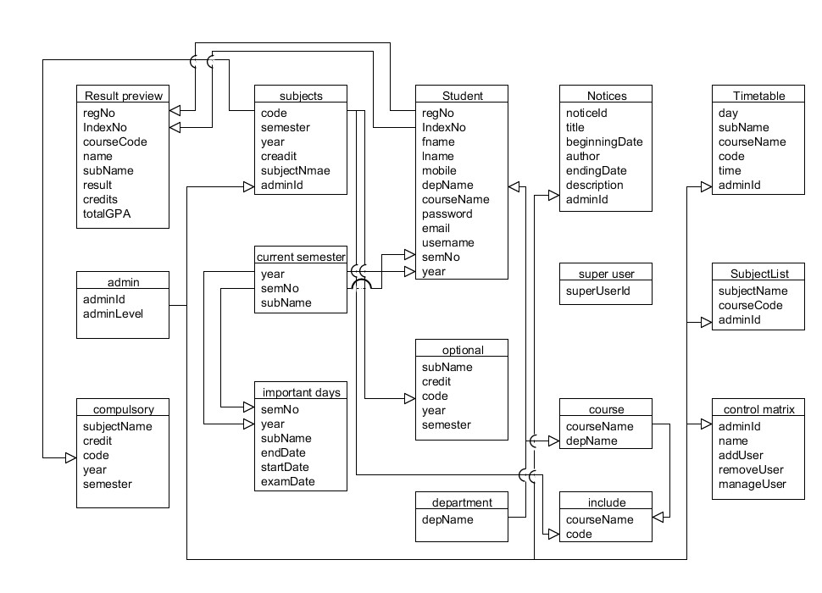

#### Figure 3.2: Database entity relationship diagram

**3.6.4 The input and output design**

Username or Registration Number

Enter Password

Login

#### Don't Have an Account? [Create Account](http://localhost/school_dev/app.php#demanppopUpWindow)

#### Figure 3.3: Login interface

User Type

Your Gender

First Name

Last Name

Phone Number

Email Address

CREATE PROFILE

#### Figure 3.4: Create Profile interface

Last Name

Gender

First Name (Surname)

Phone Number

Email

Other Name (Optional)

Year

Month

Day

Home Address

LGA of Origin

State of Origin

Relationship

Phone Number

Target Class

Sponsor Name

REGISTER

#### Figure 3.5: Complete Registration interface

## 3.7 System requirement specification

**3.7.1 Hardware requirement**

The software designed needed the following hardware for an effective operation of the newly designed system.

1. A system running on intel, P(R) duo core with higher processor
2. The-Random Access Memory (RAM) should be at least 512mb.
3. Enhanced keyboard.
4. At least 20-GB hard disk.
5. V.G.A or a colored monitor.

**3.7.2 Software Requirements**

The software requirements include:

1. A window 7 or higher version of operating system.
2. XAMP or WAMP for Database
3. PHP

**3.7.3 System User**

The following are the various users of the system.

1. Super Admin
2. Staff (Teacher)
3. Student

# CHAPTER FOUR

# RESULTS AND DISCUSSION

## 4.1 Introduction

Explain your new system’s operation that leads to the results below.

## 4.2 Results

Welcome interface



#### Figure 4.1: Welcome interface

Home page

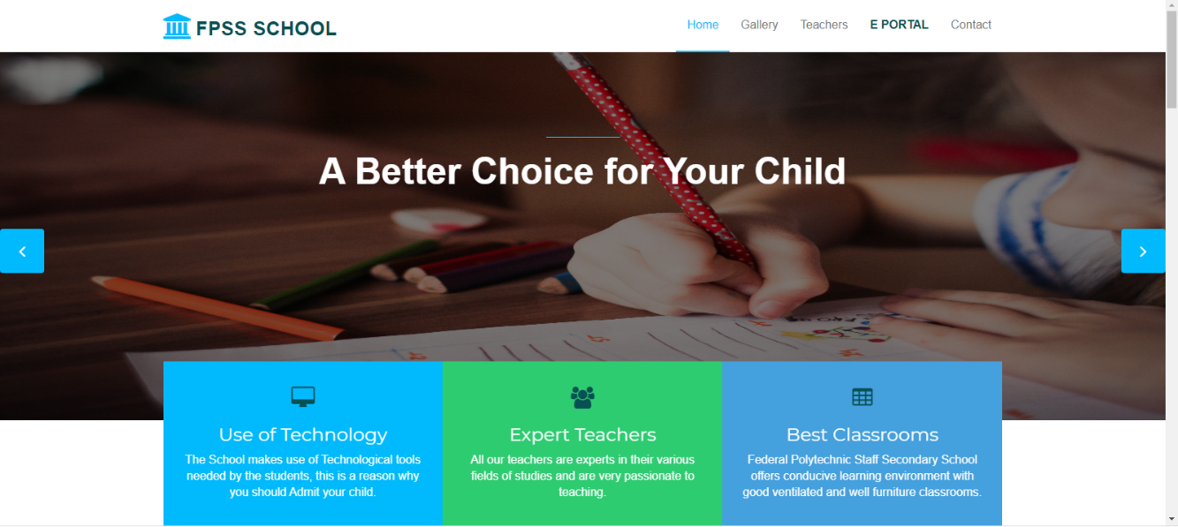

#### Figure 4.2: Home page interface

Login interface

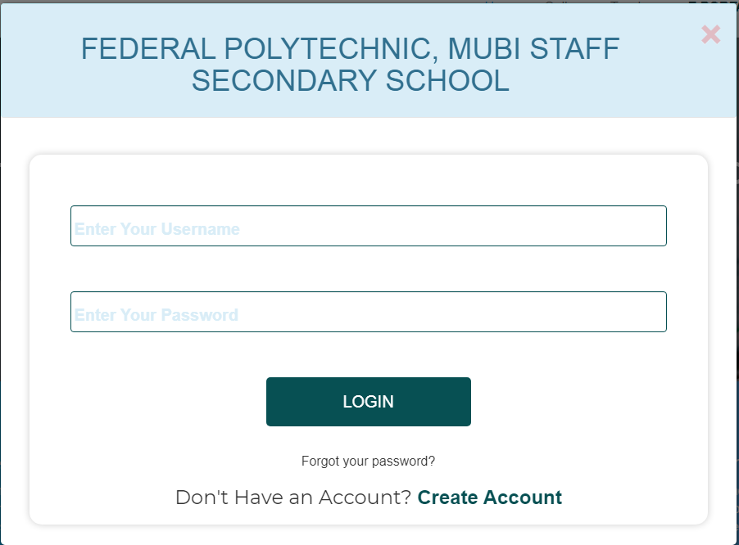

#### Figure 4.3: Login page interface

Signup interface

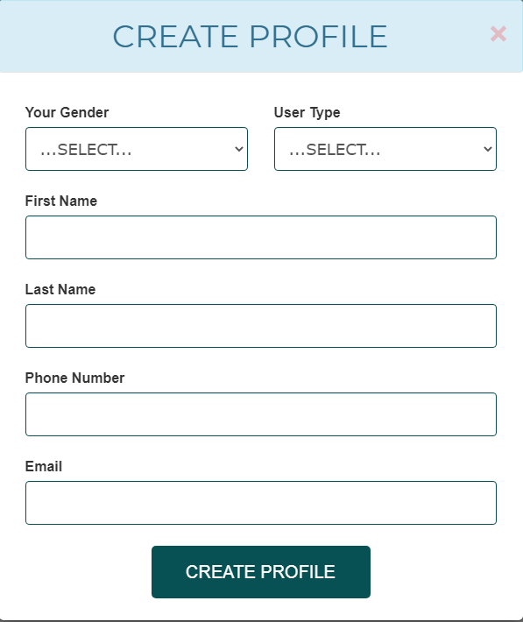

#### Figure 4.4: Signup page interface

Edit profile interface

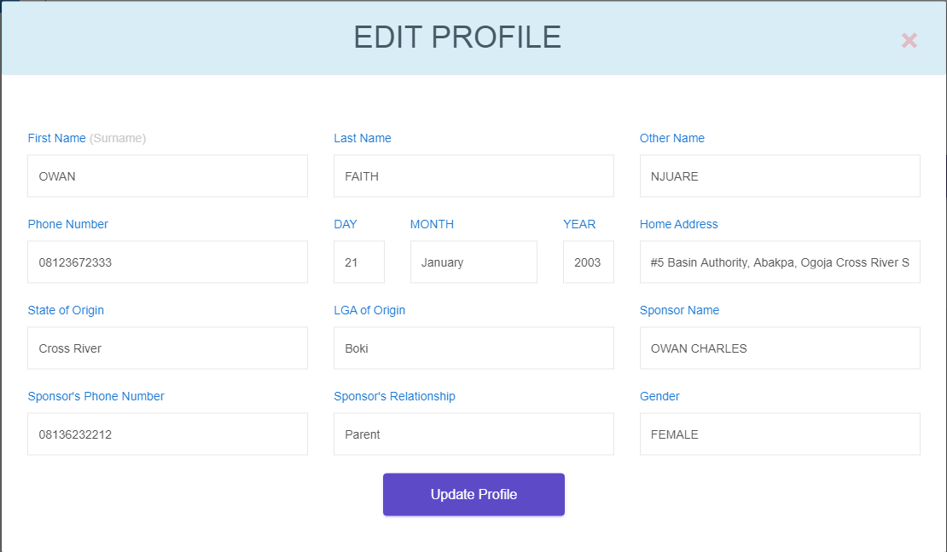

#### Figure 4.5: Edit profile page interface

Create announcement

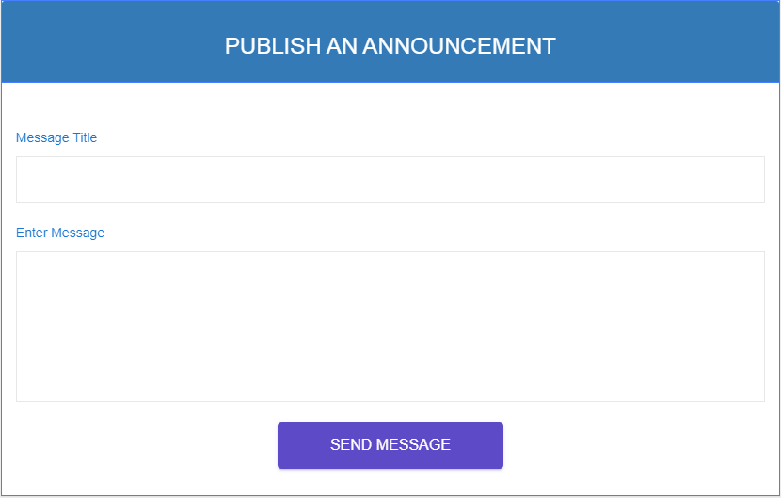

#### Figure 4.6: Create announcement interface

Announcement from Admin

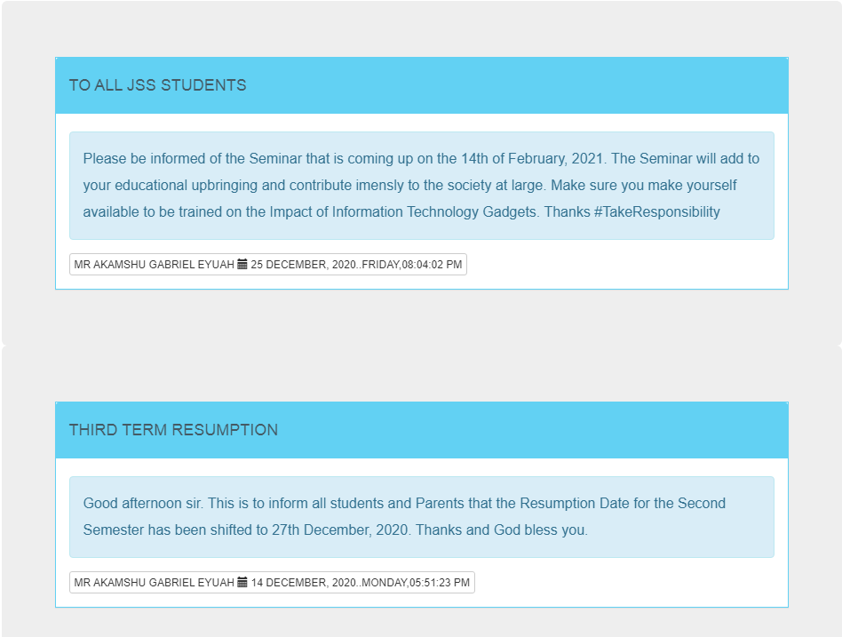

#### Figure 4.7: Announcement interface

Upload Result

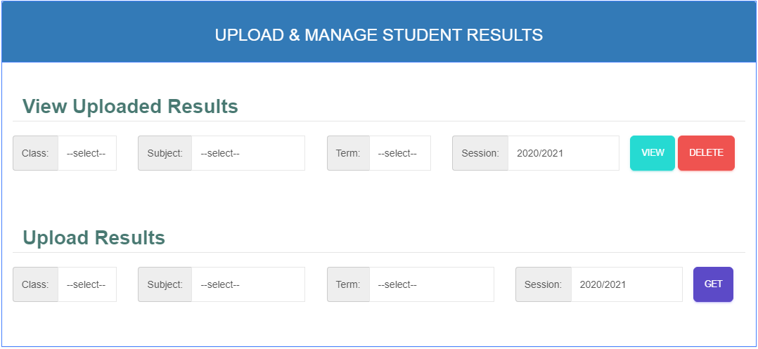

Figure 4.8: Upload result interface

Publish result

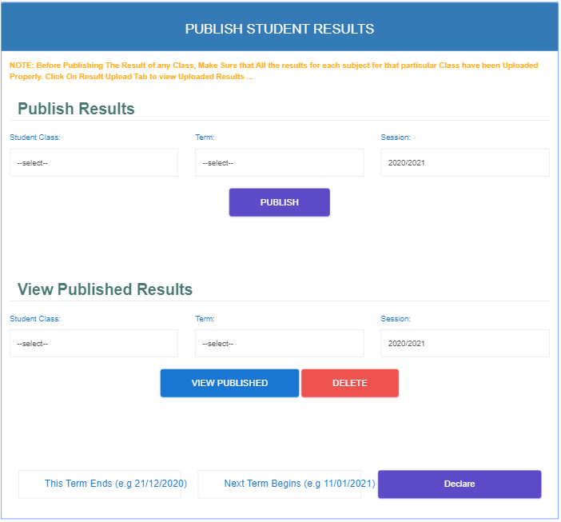

#### Figure 4.9: Publish result interface

Student registration slip

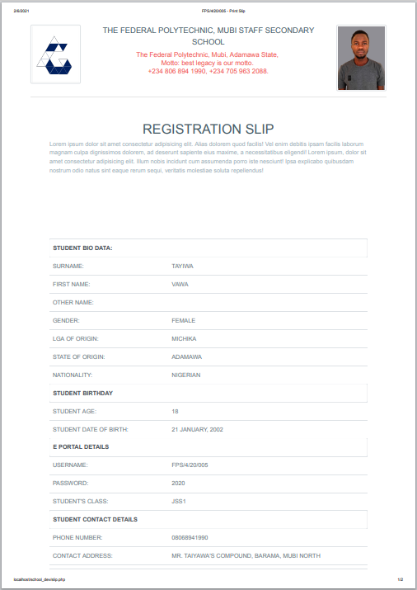

#### Figure 4.10: Student registration slip interface

Staff dashboard

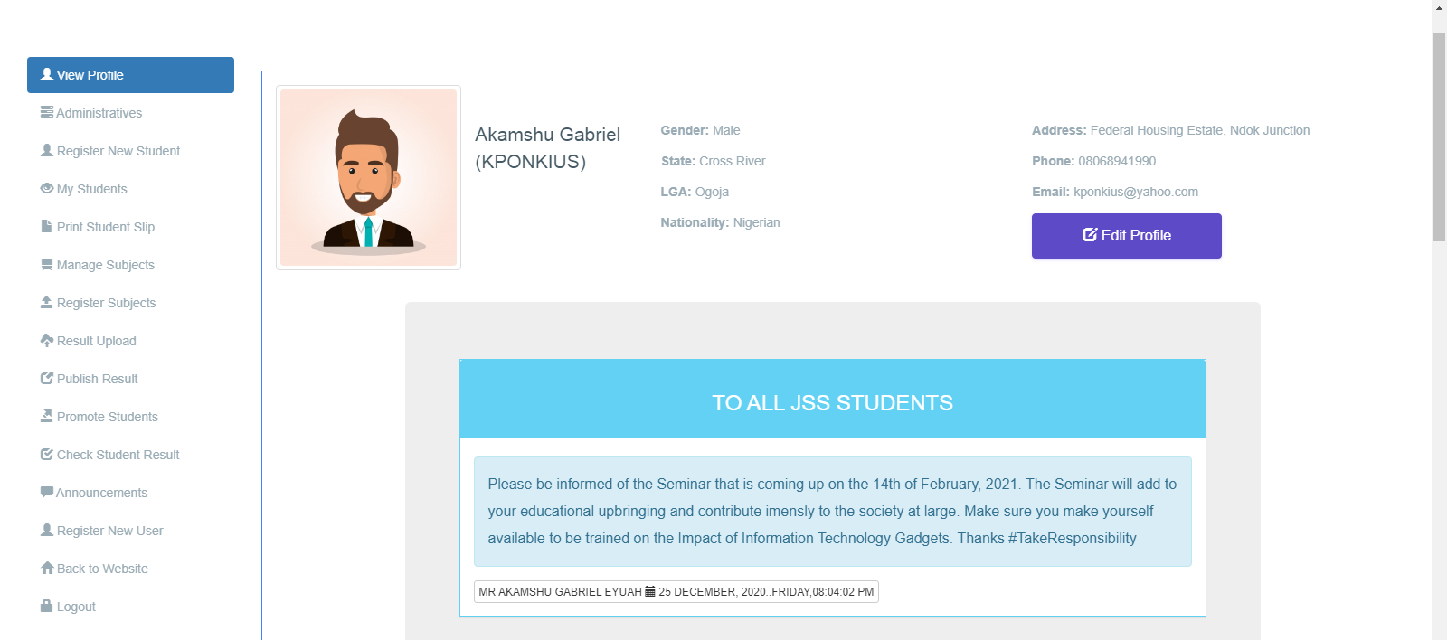

#### Figure 4.11: Staff dashboard interface

Student dashboard

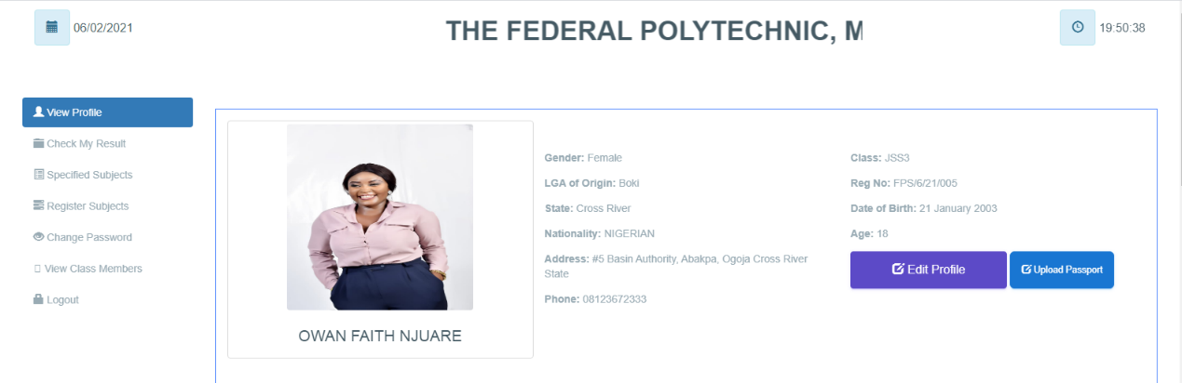

#### Figure 4.12: Student dashboard interface

## 4.3 Discussion

**Welcome interface**

This is the very first interface which welcomes the user and shows the project topic, the designer and the supervisor of the project before proceeding to the main project.

**Home page**

This section displays the home page of the school portal where the user (student or staff) can go through the various facilities that the school has and where the login link for the portal is found as well.

**Login interface**

This section is used by an existing student or teacher to login into his or her account before completing any operation.

**Signup interface**

This is the signup page that allows the user to create an account with the school portal before he or she can complete any registration.

**Create announcement**

This section is used by the Admin (Principal) to pass information on the school portal to the students.

**Upload Result**

This section is used by the admin to upload results based on the data received from C.A. and exams marks appropriate for students on a particular subject. The admin (Principal) is allowed to upload result for all classes and subjects for all students.

**Publish result**

This section is only used by the admin to published all the various results that have been uploaded by the teachers or admin for result generation.

**Student registration slip**

This section is used to print the student registration slip that will be submitted to the school management and used to get the confirmation code from the management in order to generate a matric number.

**Staff or Student dashboard**

This is the admin dashboard that is used to display all the available operations that an admin, teacher or student can perform on the school the school portal.

## 4.4 User manual

The following are the necessary steps to take in order to use the system efficiently and effectively.

1. Load the url of the system <https://localhost/school_dev/> the welcome page will be displayed.
2. Click on the **Proceed** button to proceed to the main system.
3. Click on **E PORTAL** on the navigation bar to access the portal, the login interface will be displayed.
4. Click on the **Create Account** to create a profile account with the school portal.
5. Fill the form with your correct information to enable you create an account.
6. If you created an account, provide your login details by entering your username or Registration number and password.
7. Depending on the login details provided you will be automatically directed to the dashboard.
8. The various task that you can perform on the portal will be displayed on the sidebar of the dashboard.

# CHAPTER FIVE

# SUMMARY, CONCLUSION AND RECOMMENDATION

## 5.1 Summary

The new system was designed in such a way that records about of the student that of Federal Polytechnic, Mubi Staff Secondary school will be stored in a database for easy retrieval and manipulation of data that can be accessible from any place reducing the overcrowding in the management office for registration. The new system will also help the school to generate funds through the sale of Scratch cards.

## 5.2 Conclusion

The student Eportal was designed and implemented, the aim and specific objectives of the project were achieved successfully.

## 5.3 Recommendations

The researcher puts forward the following recommendations:

1. The school management should imbibe the use of this technology in carrying out her tasks in order to reduce the time wastage that is involved with the manual system.
2. The researcher also recommends that the system be put to effective use in order to derive the necessary efficiency of the system.

## 5.4 Contribution to Knowledge

The new system was designed in a structured and robust way employing responsive design to it to ensure usability and efficiency. The project research will serve as a reference point for other research work and contribute immensely to knowledge for those conducting a research on similar topic.

## 5.5 Area for further work

The research work limited in making online payment. Therefore, the researcher suggests that further studies be conducted to include the payment of fees online.

# REFERENCES

Abuhamdieh, H. & Sehwail, L. (2017). A comparative study of campus portal user acceptance: *Student and faculty perspectives Journal of STEM Education, 8(34),* 40-49.

Adepoju, S. & Osofisan, O. (2018). Website usability: A comparison of three universities websites. *Journal of Science, Technology and Mathematics Education, 1(1),* 114-121.

Astani, M. & Elhindi, M. (2018). An empirical study of university websites. *Journal of Information Systems, 10(2),* 460-465.

Allan, H. (2014). Measuring campus portal effectiveness and the contributing factors. *Campus-Wide Journal of Information Systems, 24(5),* 342-354. doi:10.1108/10650740710835760.

Babbie, E. (2014). *The Practice of Social Research*. Belmont, CA: Thomson/Wadsworth.

Brayand, G. (2014). The impact of website portals: research synthesis. *Journal of Information Systems, 16(1),* 7-30. doi:10.2308/jis.2002.16.1.7

Boye, M. (2015). Educational Portals: A way to get integrated, user-centric university information systems. *International journal of information services, 8(1),* 17-23.

Bringula, R., & Basa, S. (2016). Factors affecting faculty web porta! usability. *Journal of Educational Technology & Society, 14 (4),* 253-265.

Cappel, J. & Huang, Z. (2017). A usability analysis of company websites. *Journal of Computer Information Systems, 48(1),* 117-123.

Chen, S., Li, S. & Li, C. (2014). Recent related research in technology acceptance model: *A literature reviews Australian Journal of Business and Management Research, 1(9),* 124-127.

Davis, F. (2019). Perceived usefulness, perceived ease of use, and user acceptance of information technology. *Journal of Management Information System, 13(3),* 319-340.

Doll, J. & Torkzadeh, A. (1988). *White paper eleven enterprise web customer case studies*: Plumtree Software, San Francisco, CA

Fuangvut, J. & Hasan, D. (2015). Begin with the end (user) in mind: Planning for the San Diego State University campus portal. In Jafari, A., & Sheehan, M. (Eds.), Designing Portals: Opportunities and Challenges (127-161). PA: Hershey.

Gerd, J. (2015). Measuring campus portal effectiveness and the contributing factors. *Campus-Wide Journal of Information Systems, 24(5),* 342-354. doi:10.1108/10650740710835760.

Hasan, H. (2013). *Accommodating inter-generational stakeholders in a campus portal.* Retrieved January 11, 2020, from <http://www.iseing.org/emcis/EMCIS2005/pdfs/22.pdf>

Hasan, L. (2013). Using university ranking systems to predict usability of university websites*. Journal of Information Systems and Technology Management, 10(2),* 235 250 DOI: 10.4301/S1807-17752013000200003 ISO 9241-11 (1998).

Ives, B. (2013). The measurement of user information satisfaction. *Journal of communication, 26(10),* 785-793. doi:10.1145/358413.358430

Lim, H. (2014). *Cross cultural differences in online learning motivation*. Paper presented at the Academy of Human Resources Development International Conference. Retrieved November 27, 2020 from http;//www.editlib.org/p/59841.

Lim, K. (2014). *The role of corporate portal on consolidating an organization’s internal and external information and knowledge repositories*. Retrieved February 12, 2020 from http:/Avww.bing.com/search?q=Full+Text+Mobile+PDF&src=IE-SearchBox&FORM=IE8SRC

Mahmood, M., Burn, J., Gemoets, L., & Jacquez, C. (2010). Variables affecting information technology end-user satisfaction: A meta-analysis of the empirical literature. *International Journal of Human-Computer Studies, 52(5),* 751-771. doi:10.1006/ijhc.1999.0353.

Masrek, N. (2017). Measuring campus portal effectiveness and the contributing factors. *Campus-Wide Journal of Information Systems, 24(5),* 342-354. doi:10.1108/10650740710835760.

McKinney, V., Yoon, K., & Zahedi, F. (2012). The measurement of web-customer satisfaction: An expectation and disconfirmation approach. *Journal of Information System Research, 13(3),* 296-315.

Mentes, S. & Turan, H. (2012). Assessing the usability of university websites: An emipirical study on Namik Kemal University. *Turkish Online Journal of Educational Technology, 2 (3),* 61-69.

Moskowitz, R. (2011). Campus portals: Come to higher education. Matrix: *The Magazine for Leaders in Higher Education, 2(3),* 54(3).

Okene, F. & Enukpere, V. (2011). Comparative analysis of the usability of academic websites of Delta State Polytechnics. *Journal of Emerging Trends in Engineering and Applied Sciences, 2(6)*, 1042-1046.

Olalekan, A. & Adepoju, T. (2012). Usability study of some selected functional websites in Nigeria. *African Journal of Computing & Information Communication Technology, 5 (3),* 57-70.

Ovem, J. (2015). *Designing Portals:* Opportunities and Challenges. Hershey, PA: Information Science Publishing, New Jersey.

Pierce, K. (2015). *Web site usability report for Harvard University*. Retrieved 24" November, 2020 from <http://digitalcommons.utep.edu/cgi/viewcontent.ogi?>

Pierece, A. (2015). *An Overview of corporate portal technology and development*: Survey results from organizations that have deployed corporate portal. Retrieved July 8, 2020 from <http://www.plumtree.com/pdf/>

Rai, A. (2012). Assessing the validity of IS success models: An empirical test and theoretical analysis. *Information Systems Research Journal, 13(1),* 50-69. doi:10.1287/isre.13.1. 50. 96

Rao, S. (2013). Distance education and the role of IT in India. *The Electronic Library, 24(3),* 225-236. doi:10.1108/026404706 10660396

Reus, A. (2013). Assessing the validity of IS success models: An empirical test and theoretical analysis. *Information Systems Research Journal, 13(1),* 50-69. doi:10.1287/isre.13.1.50.96

Richard, V. (2016). Returns on investments in information technology: A research synthesis. *Journal of Information Systems, 16(1),* 7-30. doi:10.2308/jis.2002.16.1.7

Roberts-Witt, S. (2019). User satisfaction with business-to-employee \_ portals: Conceptualization and scale development. *European Journal of Information Systems, 17(6),* 649-667. doi:10.1057/ejis.2008.55

Sharma, S. & Gupta, J. (2015). *Web portals: The new gateways to Internet information and services.* Idea Group Publishing: Hershey

Sugianto, L., & Tojib, D. R. (2017). Facilitating Employees with B2E Portal. In Proceedings of the 7" International Research Conference on Quality Innovation and Knowledge Management (pp. 553-560).

Tella, A. & Bashorun, T. (2012). Undergraduate students’ satisfaction with the use of web portals. *International Journal of Web Portals 4(2)*, 52-73. DOI: 10.4018/jwp.2012040104h

Tojib, S. (2018). *A conceptual model for B2E portal model satisfaction*. Retrieved May 12, 2020 from <https://bai2006.atisr.org/CD/Papers/2006bai6315.doc>

Worjtkowski, W. & Major, M. (2015). *Online portals:* The new gateways to Internet information and services. Idea Group Publishing: Hershey

Zaphiris, P. & Ellis, D. (2013). *Website usability and content accessibility of the top USA universities*. Retrieved February 4, 2021 from <http://pzaphiri.agrino.org/Papers/accessibilitywebnet.pdf>

# APPENDIX A

Welcome interface



Home page



Login interface



Signup interface



Edit profile interface



Create announcement



Announcement from Admin



Upload Result



Publish result



Student registration slip



Staff dashboard



Student dashboard



# APPENDIX B

**PROGRAM CODE**

|  |  |
| --- | --- |
|  |  |
|  |  |
|  |  |
|  | <!DOCTYPE html> |
|  | <html lang="en"> |
|  | <head> |
|  | <meta charset="utf-8"> |
|  | <meta http-equiv="X-UA-Compatible" content="IE=edge"> |
|  | <meta name="viewport" content="width=device-width, initial-scale=1"> |
|  | <title>FPS Secondary School | Home</title> |
|  |  |
|  | <!-- Favicon --> |
|  | <link rel="shortcut icon" href="[assets/img/favicon.ico](http://localhost/school_dev/assets/img/favicon.ico)" type="image/x-icon"> |
|  |  |
|  | <!-- Font awesome --> |
|  | <link href="[assets/css/font-awesome.css](http://localhost/school_dev/assets/css/font-awesome.css)" rel="stylesheet"> |
|  |  |
|  |  |
|  | <!-- Bootstrap --> |
|  | <link href="[assets/css/bootstrap.css](http://localhost/school_dev/assets/css/bootstrap.css)" rel="stylesheet"> |
|  | <!-- Slick slider --> |
|  | <link rel="stylesheet" type="text/css" href="[assets/css/slick.css](http://localhost/school_dev/assets/css/slick.css)"> |
|  | <!-- Fancybox slider --> |
|  | <link rel="stylesheet" href="[assets/css/jquery.fancybox.css](http://localhost/school_dev/assets/css/jquery.fancybox.css)" type="text/css" media="screen" /> |
|  | <!-- Theme color --> |
|  | <link id="switcher" href="[assets/css/theme-color/default-theme.css](http://localhost/school_dev/assets/css/theme-color/default-theme.css)" rel="stylesheet"> |
|  |  |
|  | <!-- Main style sheet --> |
|  | <link href="[assets/css/style.css](http://localhost/school_dev/assets/css/style.css)" rel="stylesheet"> |
|  | <link rel="stylesheet" href="[popup\_style.css](http://localhost/school_dev/popup_style.css)"> |
|  |  |
|  | <!-- Google Fonts --> |
|  | <link href='<https://fonts.googleapis.com/css?family=Montserrat:400,700>' rel='stylesheet' type='text/css'> |
|  | <link href='<https://fonts.googleapis.com/css?family=Roboto:400,400italic,300,300italic,500,700>' rel='stylesheet' type='text/css'> |
|  |  |
|  |  |
|  | </head> |
|  | <body> |
|  |  |
|  |  |
|  |  |
|  |  |
|  | <!--START SCROLL TOP BUTTON --> |
|  | <a class="scrollToTop" href="[#](http://localhost/school_dev/app.php)"> |
|  | <i class="fa fa-angle-up"></i> |
|  | </a> |
|  | <!-- END SCROLL TOP BUTTON --> |
|  |  |
|  | <!-- LOADER --> |
|  | <div id="preloader"> |
|  | <div class="loader-container"> |
|  | <div class="progress-br float shadow"> |
|  | <div class="progress\_\_item"></div> |
|  | </div> |
|  | </div> |
|  | </div> |
|  | <!-- END LOADER --> |
|  |  |
|  | <!-- Start menu --> |
|  | <section id="mu-menu"> |
|  | <nav class="navbar navbar-default" role="navigation"> |
|  | <div class="container"> |
|  | <div class="navbar-header"> |
|  | <!-- FOR MOBILE VIEW COLLAPSED BUTTON --> |
|  | <button type="button" class="navbar-toggle collapsed" data-toggle="collapse" data-target="#navbar" aria-expanded="false" aria-controls="navbar"> |
|  | <span class="sr-only">Toggle navigation</span> |
|  | <span class="icon-bar"></span> |
|  | <span class="icon-bar"></span> |
|  | <span class="icon-bar"></span> |
|  | </button> |
|  | <!-- LOGO --> |
|  | <!-- TEXT BASED LOGO --> |
|  | <a class="navbar-brand" href="[index.html](http://localhost/school_dev/index.html)"><i class="fa fa-university"></i><span>FPSS School</span></a> |
|  | <!-- IMG BASED LOGO --> |
|  | <!-- <a class="navbar-brand" href="index.html"><img src="assets/img/logo.png" alt="logo"></a> --> |
|  | </div> |
|  | <div id="navbar" class="navbar-collapse collapse"> |
|  | <ul id="top-menu" class="nav navbar-nav navbar-right main-nav"> |
|  | <li class="active"><a href="[index.html](http://localhost/school_dev/index.html)">Home</a></li> |
|  | <li><a href="[#mu-gallery](http://localhost/school_dev/app.php#mu-gallery)">Gallery</a></li> |
|  | <li class="nav-item"><a class="nav-link" href="[#mu-latest-courses](http://localhost/school_dev/app.php#mu-latest-courses)">Teachers</a></li> |
|  | <li><a class="hover-btn-new log orange" href="[#login](http://localhost/school_dev/app.php#login)" |
|  | data-toggle="modal" data-target="#login"><span>E PORTAL</span></a></li> |
|  | <li><a href="[#](http://localhost/school_dev/app.php)">Contact</a></li> |
|  | <li></li> |
|  | </ul> |
|  | </div><!--/.nav-collapse --> |
|  | </div> |
|  | </nav> |
|  | </section> |
|  | <!-- End menu --> |
|  | <!-- Start search box --> |
|  | <div id="mu-search"> |
|  | <div class="mu-search-area"> |
|  | <button class="mu-search-close"><span class="fa fa-close"></span></button> |
|  | <div class="container"> |
|  | <div class="row"> |
|  | <div class="col-md-12"> |
|  | <form class="mu-search-form"> |
|  | <input type="search" placeholder="Type Your Keyword(s) & Hit Enter"> |
|  | </form> |
|  | </div> |
|  | </div> |
|  | </div> |
|  | </div> |
|  | </div> |
|  | <!-- End search box --> |
|  |  |
|  |  |
|  |  |
|  |  |
|  |  |
|  | <!-- Modal --> |
|  | <div data-backdrop='static' class="modal fade" id="login" tabindex="-1" role="dialog" aria-labelledby="myModalLabel"> |
|  | <div class="modal-dialog modal-dialog-centered modal-md" role="document"> |
|  | <div class="modal-content"> |
|  | <div class="modal-header tit-up alert alert-info"> |
|  | <button type="button" class="close" style='color:red; font-size:50px;' data-dismiss="modal" aria-hidden="true">&times;</button> |
|  | <h1 class='h1 text-center' style='text-transform:uppercase; max-width:95%;'>Federal Polytechnic, Mubi Staff Secondary School</h1> |
|  | </div> |
|  |  |
|  | <div class="modal-body"> |
|  | <!-- <h1 style='text-align:center;'>LOGIN TO YOUR ACCOUNT</h1> --> |
|  | <div class="inner" id="Login" > |
|  | <form autocomplete="autocomplete\_off\_kponk" method='POST' action="/school\_dev/app.php" > |
|  | <br> |
|  | <!-- <input name='hidden' class="form-control" id="" placeholder=" " type="text" autocomplete='false' style='display:none;'> --> |
|  |  |
|  | <label class="form-group" for="email1"> |
|  | <input name='login\_id' class="form-control" id="email1" placeholder=" " type="text" autocomplete="off\_kponk" required> |
|  | <span>Enter Your Username </span> |
|  | <span class='border'></span> |
|  | </label> |
|  |  |
|  | <label class="form-group" for="exampleInputPassword1"> |
|  | <input class="form-control" id="exampleInputPassword1" placeholder=" " name="login\_password" type="password" autocomplete='kponk\_off' required> |
|  | <span>Enter Your Password</span> |
|  | <span class='border'></span> |
|  | </label> |
|  | <div class="row text-center"> |
|  | <p class='text-center'><input type="submit" name="login\_btn" class="" value="LOGIN"></p> |
|  |  |
|  | <p lass="text-center" ><a href="[javascript:;](about:blank" \t "_blank)">Forgot your password?</a></p> |
|  | <h4> Don't Have an Account? <a href="[#demanppopUpWindow](http://localhost/school_dev/app.php#demanppopUpWindow)" data-toggle="modal" data-target="#demanppopUpWindow" data-dismiss="modal" > <span>Create Account</span></a> </h4> |
|  | </div> |
|  | </form> |
|  | </div> |
|  | </div> |
|  | </div> |
|  | </div> |
|  | </div> |
|  |  |
|  |  |
|  | <!-- Start Slider --> |
|  | <section id="mu-slider"> |
|  | <!-- Start single slider item --> |
|  | <div class="mu-slider-single"> |
|  | <div class="mu-slider-img"> |
|  | <figure> |
|  | <img src="[assets/img/slider/4.jpg](http://localhost/school_dev/assets/img/slider/4.jpg)" alt="img"> |
|  | </figure> |
|  | </div> |
|  | <div class="mu-slider-content"> |
|  | <span></span> |
|  | <h2>We Will Help Your Child/Ward To Learn</h2> |
|  | </div> |
|  | </div> |
|  | <!-- Start single slider item --> |
|  | <!-- Start single slider item --> |
|  | <div class="mu-slider-single"> |
|  | <div class="mu-slider-img"> |
|  | <figure> |
|  | <img src="[assets/img/slider/8.jpg](http://localhost/school_dev/assets/img/slider/8.jpg)" alt="img"> |
|  | </figure> |
|  | </div> |
|  | <div class="mu-slider-content"> |
|  | <span></span> |
|  | <h2>A Better Choice for Your Child</h2> |
|  |  |
|  | </div> |
|  | </div> |
|  | <!-- Start single slider item --> |
|  | <!-- Start single slider item --> |
|  | <div class="mu-slider-single"> |
|  | <div class="mu-slider-img"> |
|  | <figure> |
|  | <img src="[assets/img/slider/9.jpg](http://localhost/school_dev/assets/img/slider/9.jpg)" alt="img"> |
|  | </figure> |
|  | </div> |
|  | <div class="mu-slider-content"> |
|  | <span></span> |
|  | <h2>"Train up a child in the way he should grow"</h2> |
|  |  |
|  | </div> |
|  | </div> |
|  | <!-- Start single slider item --> |
|  | <!-- Start single slider item --> |
|  | <div class="mu-slider-single"> |
|  | <div class="mu-slider-img"> |
|  | <figure> |
|  | <img src="[assets/img/slider/10.jpg](http://localhost/school_dev/assets/img/slider/10.jpg)" alt="img"> |
|  | </figure> |
|  | </div> |
|  | <div class="mu-slider-content"> |
|  | <span></span> |
|  | <h2>Five Times Award for Best Secondary School</h2> |
|  | </div> |
|  | </div> |
|  | <!-- Start single slider item --> |
|  | <!-- Start single slider item --> |
|  | <div class="mu-slider-single"> |
|  | <div class="mu-slider-img"> |
|  | <figure> |
|  | <img src="[assets/img/slider/5.jpg](http://localhost/school_dev/assets/img/slider/5.jpg)" alt="img"> |
|  | </figure> |
|  | </div> |
|  | <div class="mu-slider-content"> |
|  | <span></span> |
|  | <h2>Best Secondary School Educational Standard</h2> |
|  | </div> |
|  | </div> |
|  | <!-- Start single slider item --> |
|  | <!-- Start single slider item --> |
|  | <div class="mu-slider-single"> |
|  | <div class="mu-slider-img"> |
|  | <figure> |
|  | <img src="[assets/img/slider/6.jpg](http://localhost/school_dev/assets/img/slider/6.jpg)" alt="img"> |
|  | </figure> |
|  | </div> |
|  | <div class="mu-slider-content"> |
|  | <h4>Your Child/Ward Deserves Better Education</h4> |
|  | <span></span> |
|  | <h2>Education is a Right For Everyone</h2> |
|  | </div> |
|  | </div> |
|  | <!-- Start single slider item --> |
|  | </section> |
|  | <!-- End Slider --> |
|  | <!-- Start service --> |
|  | <section id="mu-service"> |
|  | <div class="container"> |
|  | <div class="row"> |
|  | <div class="col-lg-12 col-md-12"> |
|  | <div class="mu-service-area"> |
|  | <!-- Start single service --> |
|  | <div class="mu-service-single"> |
|  | <span class="fa fa-desktop"></span> |
|  | <h3>Use of Technology</h3> |
|  | <p>The School makes use of Technological tools needed by the students, this is a reason why you should Admit your child.</p> |
|  | </div> |
|  | <!-- Start single service --> |
|  | <!-- End service --> |
|  |  |
|  | <!-- Start about us --> |
|  | <section id="mu-about-us"> |
|  | <div class="container"> |
|  | <div class="row"> |
|  | <div class="col-md-12"> |
|  | <div class="mu-about-us-area"> |
|  | <div class="row"> |
|  | <div class="col-lg-6 col-md-6"> |
|  | <div class="mu-about-us-left"> |
|  | <!-- Start Title --> |
|  | <div class="mu-title"> |
|  | <h2>About FPSSS</h2> |
|  | </div> |
|  | <!-- End Title --> |
|  | <p>Federal Polytechic, Mubi Staff Secondary School (FPSSS), is </p> |
|  | <ul> |
|  | <li>Lorem ipsum dolor sit amet, consectetur adipisicing elit.</li> |
|  | <li>Saepe a minima quod iste libero rerum dicta!</li> |
|  | <li>Voluptas obcaecati, iste porro fugit soluta consequuntur. Veritatis?</li> |
|  |  |
|  |  |
|  | <!------------- MODAL SECTION BEGINS HERE (ITEM ORDER MODAL) -----------> |
|  |  |
|  | <!-- ADMIN EDIT MODAL BEGINS HERE --> |
|  | <div class='modal fade' id='demanppopUpWindow'> |
|  | <div class='modal-dialog'> |
|  | <div class='modal-content'> |
|  | <div class='modal-header alert alert-info'> |
|  | <button type='button' class='close' data-dismiss='modal' style='font-size:40px;color:red;'title='Close'>&times;</button> |
|  | <h1 class='modal-title text-center'>CREATE PROFILE</h1> |
|  | </div> |
|  | <div class='modal-body'> |
|  | <form method='POST' action='app.php' role='form' enctype=""> |
|  | <div class='col-md-6 field half'> |
|  | <Select type='text' id='userGender' required class='form-control' name='userGender' style='text-transform:uppercase;'> |
|  | <option value="">...Select...</option> |
|  | <option value="Female">Female</option> |
|  | <option value="Male">Male</option> |
|  | </select> |
|  | <label class='form-label' for='userType'>Your Gender</label> |
|  | </div> |
|  | <div class='col-md-6 field half'> |
|  | <Select type='text' id='userType' required class='form-control' name='userType' style='text-transform:uppercase;'> |
|  | <option value="">...Select...</option> |
|  | <option value="Student">Student</option> |
|  | <option value="Teacher">Teacher</option> |
|  | </select> |
|  | <label class='form-label' for='userType'>User Type</label> |
|  | </div> |
|  | <div class='col-md-6 field half'> |
|  | <input type='text' id='userFirstName' required value='' class='form-control' name='fname' style='text-transform:uppercase;'/> |
|  | <label class='form-label' for='userFirstName'>First Name</label> |
|  | </div> |
|  |  |
|  | <div class='col-md-6 field half'> |
|  | <input id='userLastNme' name='lname' required value='' required class='form-control' placeholder='' aria-describedby='' style='text-transform:uppercase;'> |
|  | <label class='form-label' for='userLastNme'>Last Name</label> |
|  | </div> |
|  |  |
|  | <div class='col-md-12 field half'> |
|  | <input maxlength='11' id='userPhone' onkeypress='isInputNumber(event)' type='text' value='' class='form-control' name='userPhone' required> |
|  | <label class='form-label' for='userPhone'>Phone Number</label> |
|  |  |
|  | </div> |
|  |  |
|  |  |
|  | <div class='col-md-12 field half'> |
|  | <input type='text' id='userEmail' required value='' class='form-control' name='userEmail' /> |
|  | <label class='form-label' for='userEmail'>Email</label> |
|  |  |
|  | </div> |
|  |  |
|  |  |
|  |  |
|  |  |
|  | <p class='text-center'><input type='submit' name='createProfile' style='text-transform:uppercase;' value='Create Profile' class='btn btn-primary btn-md' /></p> |
|  | </form> |
|  | </div> |
|  | </div> |
|  | <!-- END OF ADMIN MODAL --> |
|  | <footer id="footers" style="padding: 20px 0;text-align: center;"> |
|  | <div class="container text-center"> |
|  | <div class="fnav"> |
|  | <p>Copyright &copy; 2021 Kponkius. Designed by <a href="[#](http://localhost/school_dev/app.php)" rel="nofollow">Kponkius Web Team</a></p> |
|  | </div> |
|  | </div> |
|  | </div> |
|  |  |
|  |  |
|  |  |
|  |  |
|  | <!-- jQuery library --> |
|  | <script src="[assets/js/jquery.min.js](http://localhost/school_dev/assets/js/jquery.min.js)"></script> |
|  | <!-- Include all compiled plugins (below), or include individual files as needed --> |
|  | <script src="[assets/js/bootstrap.js](http://localhost/school_dev/assets/js/bootstrap.js)"></script> |
|  | <!-- Slick slider --> |
|  | <script type="text/javascript" src="[assets/js/slick.js](http://localhost/school_dev/assets/js/slick.js)"></script> |
|  | <!-- Counter --> |
|  | <script type="text/javascript" src="[assets/js/waypoints.js](http://localhost/school_dev/assets/js/waypoints.js)"></script> |
|  | <script type="text/javascript" src="[assets/js/jquery.counterup.js](http://localhost/school_dev/assets/js/jquery.counterup.js)"></script> |
|  | <!-- Mixit slider --> |
|  | <script type="text/javascript" src="[assets/js/jquery.mixitup.js](http://localhost/school_dev/assets/js/jquery.mixitup.js)"></script> |
|  | <!-- Add fancyBox --> |
|  | <script type="text/javascript" src="[assets/js/jquery.fancybox.pack.js](http://localhost/school_dev/assets/js/jquery.fancybox.pack.js)"></script> |
|  |  |
|  | <script> |
|  |  |
|  |  |
|  | function isInputNumber(evt) { |
|  | let char = String.fromCharCode (evt.which); |
|  | if(!(/[0-9]/.test(char))){ |
|  | evt.preventDefault(); |
|  | } |
|  |  |
|  | } |
|  | </script> |
|  | <!-- Custom js --> |
|  | <script src="[assets/js/custom.js](http://localhost/school_dev/assets/js/custom.js)"></script> |
|  |  |
|  | </body> |
|  | </html> |